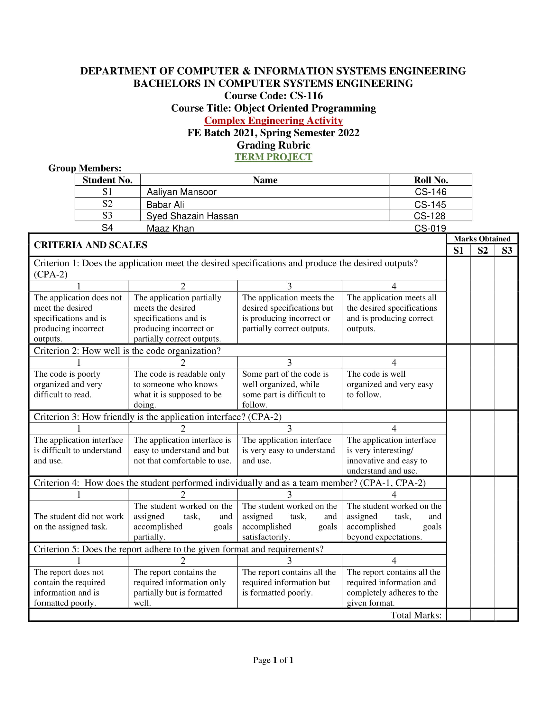



**CEP REPORT**

Object-oriented Programming cs-116

Report by:

AALIYAN MANSOOR CS-146

BABAR ALI CS-145

SYED SHAHZAIN HASSAN CS-128

MAAZ KHAN CS-019

# Problem Description:

Online Shopping Cart is a virtual shopping trolley which allows the user to put items in his/her cart by simply selecting them from the cursor. The user can select the desired quantity for each product. The user has multiple categories to browse from and he/she can shop from his/her desired category. The administrator can add or remove the items from each category.

# Distinguishing features:

* Interactive GUI
* Payment process
* Inheritance
* Association
* Method overriding
* Abstract class
* Exception handling
* More than 10 products in each category

# The most challenging part:

The most challenging parts were integrating the GUI, storing and retrieving data from files, and implementing the code according to UML.

# Future Expansions:

Future Expansions can be done by adding more shopping categories, A web interface can also be made for the application. Using the same concepts and features, some sort of bank applications can also be made or apps to keep track of finances.

The Flow of the project:

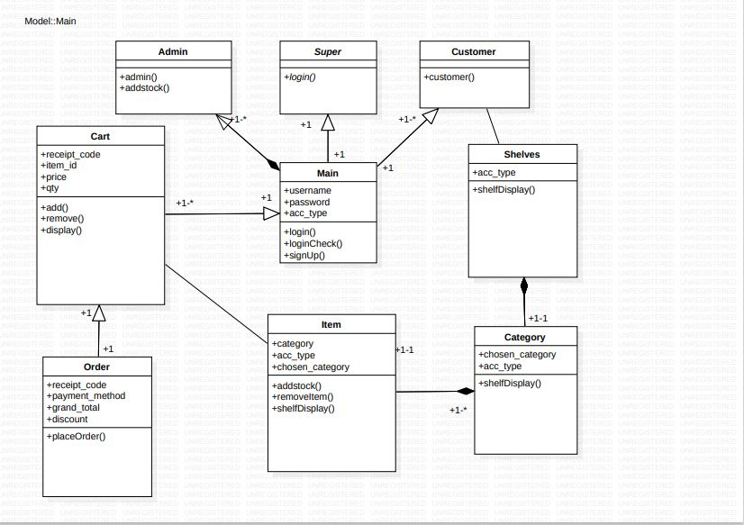

# New things learnt while working on the project:

* The Tkinter module
* Usage of class diagrams
* The UUID module (to generate unique IDs)
* Working with multiple files
* The use of f-strings.

# References:

Menu widget in Tkinter. (2019, April 12). Geeksforgeeks. Retrieved July 24, 2022, from <https://www.geeksforgeeks.org/python-menu-widget-in-tkinter/?ref=lbp>

OOP. (n.d.). Stack overflow. Retrieved July 24, 2022, from <https://stackoverflow.com/>

# Test Runs:

